**CHAPTER 1**

**INTRODUCTION**

* 1. **Overview**

Modern civilization now considers traffic monitoring to be essential, and using cameras and computers to accomplish this aim is becoming more and more common. However, in the modern era of advanced technology, manual video analysis is not only time-consuming but also impractical. In order to create intelligent traffic monitoring and management systems that conserve resources and need the least amount of human interaction, computer-based image processing technology has been created. These systems can provide sophisticated and workable monitoring programmes by analysing video pictures, detecting and identifying vehicles, and taking necessary action in the event of unexpected circumstances. The supervisory department now uses computer connection monitoring methods to accomplish the aim of intelligent traffic monitoring and management. These systems analyse video from cameras, identify cars, and do standard management activities automatically using computer and image processing technologies.They can also spot anomalous circumstances and respond to them in the best, most secure way possible. This approach is appealing to academic and corporate circles throughout the world since it saves a sizable amount of labour and material resources. Vehicle that uses vision The main approaches for object detection include classic machine vision techniques and sophisticated deep learning techniques. The former, which may be categorised into three different approaches—the technique of backdrop subtraction, the method of continuous video frame difference, and the method of optical flow—uses a vehicle's motion to distinguish it from a stationary background picture. The moving foreground region is divided by the threshold using the video frame difference approach, which computes the variance based on the pixel values of two or three successive video frames.

This technique may also detect the car halting by muzzling sounds. When the video's background image is fixed, background data is used to create a background model, which is then compared to each frame's image to identify moving objects. Through the generated optical flow field, the optical flow method can identify the motion region in the video and represent the direction and speed of each moving pixel. Another way for detecting automobiles is by the use of vehicle characteristics in machine vision, with the widely used Scale Invariant Feature Transform (SIFT) and Speeded Up Robust characteristics (SURF) approaches. In order to fulfil vehicle recognition and classification tasks, 3D models have also been used. Vehicles may be categorised using the correlation curves of 3D ridges on their exterior.In today's culture, keeping an eye on traffic situations has become essential, and using cameras and computers to do so is growing in popularity. Intelligent traffic monitoring and management systems can now analyse video data, recognise and identify cars, and take necessary action in case of abnormal situations all without the need for human interaction thanks to advancements in computer-based image processing technology.

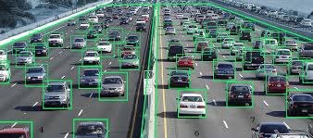

Fig 1.1 Vehicle detection using CNN.

Along with vehicle features like SIFT and SURF, machine vision techniques like background subtraction, continuous video frame difference, and optical flow are frequently used to detect vehicles. Using 3D models can also help with vehicle identification and categorization. These technology developments in traffic monitoring and management have significant academic and economic value, making them desirable choices.Without making a conscious effort, the Human Vision System (HVS) excels in differentiating between various objects. Recent advances in computer vision (CV) and machine learning (ML) have made it possible for computers to accurately detect, identify, and categorise objects in photos and videos. Effective vehicle detection and categorization are essential for monitoring or observing traffic. Utilising recent developments in CV and ML technologies, including large datasets, faster GPUs, and improved algorithms, our project aims to create an effective system for locating vehicles in images and videos. Fig 1.1 Vehicle detection using CNN. Fig 1.2 Vehicle Classification is Highway scenarios Monitoring video scenes for intelligent traffic management and control on highways significantly rely on vehicle recognition and statistics. An enormous amount of traffic video material is now accessible for examination as a result of the growing installation of traffic surveillance cameras. However, a high viewing angle makes the road surface appear further away and drastically alters the size of the vehicles in the scene, making it challenging to precisely detect small objects far from the road. Furthermore, challenging camera angles make the issue worse. Therefore, it is crucial to effectively address these issues and implement them in order to get better outcomes. The accuracy of vehicle recognition and categorization in highway monitoring may be considerably increased with effective solutions to these problems.

Computer vision is one of the most fascinating sectors of technology to have undergone a deep learning revolution. Computer vision has become a crucial part of contemporary technology, used in everything from biometrics and face recognition to self-driving automobiles. Image processing, which entails transforming an image into a digital format and applying operations on it to extract valuable information, is the foundation of computer vision. Based on the quantity of pixels, images are represented by their dimensions (height and breadth). Each pixel is a spot on the picture that assumes a certain hue, level of transparency, or colour. Different representations of pixels exist, including grayscale, RGB, and RGBA. Each pixel of an image must undergo a predetermined series of operations, and the output value of these operations may be calculated at any pixel of the picture. Fig 1.3 Basic working of CNN in Vehicle Detection Analogue and digital approaches are the two categories of image processing techniques. For physical copies like printouts and images, analogue image processing is performed, and image analysts employ a variety of interpreting principles.

On the other hand, utilising computers to manipulate digital photos is made possible by digital image processing techniques. Pre-processing, augmentation, and presentation are the three main stages of digital image processing, together with information extraction. Computer vision, which is widely applied in many facets of contemporary technology, is fundamentally dependent on image processing. Image processing is crucial for obtaining valuable information from digital photos, whether it be for self-driving cars or facial identification.

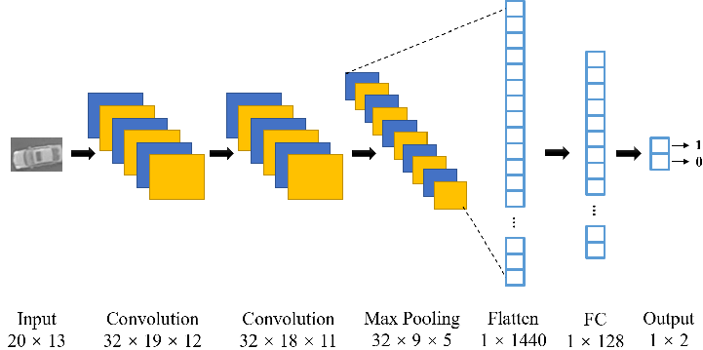

Fig 1.2 Basic working of CNN in Vehicle Detection

**1.2 Problem Statement**

Vehicle detection and statistics in highway monitoring video scenes are of considerable significance to intelligent traffic management and control of the highway. With the popular installation of traffic surveillance cameras, a vast database of traffic video footage has been obtained for analysis. Generally, at a high viewing angle, a more-distant road surface can be considered. The object size of the vehicle changes greatly at this viewing angle, and the detection accuracy of a small object far away from the road is low. In the face of complex camera scenes, it is essential to effectively solve the above problems and further apply them.

**1.3 Objective**

* To reduce the cost of labelling data.
* To prevent data scarcity.
* To create variability and flexibility in data models.
* To experiment with different pre-processing techniques and evaluate their effect on the model's performance.
* To extract the shallow and deep semantic information of the image by establishing multiple hidden layers.

**1.4 Scope**

The main contributions of this project are:

* Load the Image Dataset
* Image Preprocessing
* Image Vectorization
* Training the Model
* Testing of Test Data

**1.5 Motivation**

The Human Vision System (HVS) reliably and accurately performs complex tasks, such as being able to detect and recognize and identify a diverse range of objects with little conscious attention. With the recent developments in the Computer Vision (CV) and Machine Learning (ML), and with the availability of capabilities, such as massive data sets, faster GPUs, and better algorithms, it has now become possible for computers to detect, recognize, and classify several items in an image or video with high accuracy . The aim of vehicle detection and classification is to locate vehicles in either images or videos . Efficiency of vehicle localization is a critical step in traffic monitoring or surveillance. This motivates us to develop this project.

**1.6 Organization of the Report**

The report is organized in the manner as follows:

**Chapter 1** presents the introduction about network intrusion detection systems.

**Chapter 2** is about literature survey that provides an overview to the topics required for the system along with the methods used by other publishers.

**Chapter 3** contains a brief look into all previous methods and existing models which are being examined. The system configurations such as software and hardware requirements, are mentioned.

**Chapter 4** consists of the module description which gives a brief description of each of our modules listed.

**Chapter 5** gives us results and discussion containing the tools and methods that were used to get the desired results.

**Chapter 6** explains the conclusion and future scope about the project. Different ways of extending this project are explained here.

**CHAPTER 2**

**LITERATURE SURVEY**

**2.1 Introduction**

Object detection is also one of the critical components to support autonomous driving. Autonomous vehicles rely on the perception of their surroundings to ensure safe and robust driving performance. This perception system uses object detection algorithms to accurately determine objects such as pedestrians, vehicles, traffic signs and barriers in the vehicle's vicinity. Deep learning-based object detectors play a vital role in finding and localizing these objects in real-time. This article discusses the state-of-the-art in object detectors and open challenges for their integration into autonomous vehicles. Adopting the superior compounds of deep learning visual classification methods achieved enormous accuracy in classifying visual scenes. However the visual classifiers face difficulties examining the scenes in dark visible areas especially during the nighttime. Also the classifiers face difficulties in identifying the contexts of the scenes. This paper proposed a deep learning model that reconstructs dark visual scenes to clear scenes like daylight and the method recognizes visual actions for the autonomous vehicle.

**2.2 Existing System**

Vehicle detection in various remote sensing scenes is a challenging task. Various remote sensing scenes are mixed up with images of multi scene, multi quality, multiscale, and multiclass. Vehicle detection models suffer from inadequate candidate boxes, weak positive proposal sampling, and poor classification performance, resulting in a detection performance degradation when they are applied in various scenes. What is worse, there is no such a dataset covering various scenes, which is for vehicle detection. This article proposes a vehicle detection model called double fully convolution one-stage object detection (FCOS) and a vehicle dataset called multiscene, multi quality, multiscale, and multiclass vehicle dataset (4MVD) for vehicle detection in various remote sensing scenes. Double FCOS is a two-stage detection model based on FCOS. FCOS is exploited in the RPN stage to generate candidate boxes in various scenes. The two-stage positive and negative sample model is carefully designed to enhance the positive proposal sampling effects, particularly the tiny or weak vehicles, which are ignored in FCOS. A two-step classification model has been designed in the RCNN stage with a proposal classification branch and point classification branch to enhance the classification performance be- tween the various types of vehicles. 4MVD is collected from various remote sensing scenes to evaluate the performance of double FCOS. A mean average accuracy of 78.3% for vehicle detection on ve categories has been received by double FCOS on 4MVD. Extensive experiments demonstrate that double FCOS significantly improves the performance of vehicle detection in various remote sensing scenes.

Vehicle detection is a popular topic in remote sensing re- search, with many publicly released datasets containing only one scenario and one class of vehicle. However, various remote 4742 sensing scenes contain more complex scenes in which vehicle detection is still a challenging task. A two-stage detection model called double FCOS is dedicated for vehicle detection in a variety of remote sensing scenes. The FCOS in the RPN stage is used to yield sufficient positive proposals for vehicle detection in a variety of scenes. A TPNSM is designed in the second FCOS to retain tiny and weak targets. A TSCM is proposed in the RCNN stage to achieve a precise classification of the proposals. A dataset called 4MVD, which contains a wide range of scenes and vehicles, is proposed for the evaluation of double FCOS. The effectiveness of double FCOS is demonstrated to vehicle detec- tion in various remote sensing scenes by extensive experiments.

**2.3 Drawbacks of Existing System**

* It is not an easy-to-use method
* This system is Opportunistic and uncontrollable
* Approach is a bit time-consuming
* Feature selection problem has not been dealt with effectively.
* Sensitive to the specifics of the training data.
* Low Accuracy with Dissimilar Features
* Decrease the generalizability of the model

**2.4 Literature Survey**

**2.4.1 A Hybrid Control Strategy of 7000 m-Human Occupied Vehicle Tracking Control**

**Authors:** Daqi Zhu , Wenyang Gan , Zhen Hu , Lei Yang , Xianpeng Shi and Yunsai Chen (2020)

Human Occupied Vehicle (HOV) is one of main tools to investigate submarine resources and carry out some underwater operations, and it can serve as a base for divers when they execute underwater activities. Therefore, the research on HOV is extremely significant. Aiming at the drive saturation (thrust overrun) problem of tracking control which is one of the main research directions, a hybrid control strategy based on quantum-behaved particle swarm optimization-model predictive control (QPSO-MPC) and adaptive sliding mode control (ASMC) is put forward for Jiaolong HOV. The hybrid control strategy includes a QPSOMPC-based kinematic controller and an ASMC-based dynamic controller. The kinematic controller transforms the position error into the virtual desired speed. Then the error between the desired speed and real speed is used as the input for the dynamic controller. Through the design of S sliding manifold and dynamic control law, the thrusts of 4 DOF are obtained.

The thrusts are distributed to eight thrusters in accordance with the thrusters configuration of Jiaolong HOV. So that HOV can be driven to reach and track the known reference trajectory. The innovation of this hybrid control strategy is it takes into account the limited speed for HOV. The constraints on speed and speed increment are added in the optimization part of the kinematic controller. A simple trajectory generator designed by QPSO-MPC is presented with obstacle avoidance behavior. Compared with backstepping control and bioinspired backstepping control, the proposed strategy can deal with the speed jump phenomenon and the drive saturation (thrust overrun) caused by exceeded speed variation. From the simulation results, the hybrid strategy is able to achieve stable and accurate tracking control under the condition of satisfying the physical constraints (speed and thrust constraints). And the trajectory generator is verified to be capable of trajectory planning with obstacle avoidance behavior. In order t o deal with the speed jump phenomenon and the drive saturation (thrust overrun) of HOV tracking control, a hybrid control method is pictured for trajectory tracking control of Jiaolong HOV. The developed method involves two components: kinematics and dynamics.

Efficiency :

* Eliminating the huge workload of traditional methods
* Offer increased flexibility
* Efficiently improving time efficiency, involves the computation time and communication time.

Drawbacks

* Feature selection problem has not been dealt with effectively.
* Models are very costly to train
* Problems existing in their respective network structures.

**2.4.2 An Integrated Longitudinal and Lateral Vehicle Following Control System With Radar and Vehicle**

**Authors:** Shouyang Wei , Yuan Zou , Xudong Zhang , Tao Zhang and Xiaoliang Li

2019

A control framework adopting the on-board radar sensor and vehicle-to-vehicle (V2V) communication has been developed to fulfill the automated vehicle following in the longitudinal and lateral directions. First, a linear feedforward and feedback controller constrained by the string stability is designed to follow the velocity of the preceding vehicle and ensure a safe inter-vehicle distance. Then, a path estimation method is proposed to calculate the trajectory of the preceding vehicle based on its historical movement data transmitted by V2V. The model predictive control method is applied to regulate the steering angle of the front wheel. Furthermore, the robustness and adaptability of the proposed method are validated by simulations and tests under several driving conditions. The results indicate that the proposed method shows the reliable performance to realize the longitudinal and lateral vehicle following only by radar and V2V, independent of high-accuracy positioning system and road marking, and is promising to expand available areas of automated vehicle platooning. proposed control algorithm, it is assumed the geometry size of the vehicle is overlooked, but the radar can only detect the rear bumper of the preceding vehicle and often regard one of the two rear corners as the tracking point, which makes the estimated path of the preceding vehicle deviate from its actual path. To cope with this problem, a vision system with multi-sensor fusion algorithm can be used to accurately detect the middle of the preceding vehicle's rear end. This paper proposes a n integrated longitudinal a n d lateral in vehicle following scenarios with control framework millimeter wave radar and V2V communication. The acceleration of the preceding vehicle, inter-vehicle range, and velocity difference are adopted to design a linear longitudinal controller to realize a fast and smooth velocity tracking and string stability. A path estimation algorithm i s proposed to calculate the driving path of the preceding vehicle based o n its historical movement. A nonlinear bicycle model i s used to represent lateral vehicle dynamics.

Efficiency

* Provides more flexibility when designing models.
* May not meet the real-time requirement.
* Has the best acceptance ratio

Drawbacks

* Increases computation time, reduces interpretability.
* Tedious message updating
* High complexity of installing and maintaining

**2.4.3 Control-Configured-Vehicle Design and Implementation on an X-by-Wire Electric Vehicle**

**Authors:** Jun Ni , Jibin Hu and Changle Xiang(2018)

To improve the structure layout flexibility and performance of the X-by-wire (XBW) ground vehicle, the control configured vehicle (CCV) principle is implemented on an XBW electric vehicle in this paper. By including the electric control system design together with the mechanical component design for the final layout, the CCV enhances the structure layout flexibility of the XBW ground vehicle considerably. Under the CCV principle, the closed-loop stability of the vehicle lateral dynamics system is improved by the involved yaw control system. In this paper, a robust pole assignment yaw controller with the consideration of parametric uncertainties is used. A full XBW electric vehicle testbed is shown as an example to demonstrate the benefit of the CCV of improving the hardware layout flexibility. Under the CCV, all the XBW components can be located flexibly to any position to enhance the configuration of the electric wires, saving of the space, and convenience of the assembling. The discussion of the yaw moment demand in different cases shows how the mechanical components and electric control systems influence and benefit each other in the CCV. The experiments based on the testbed show the desirable efficiency of the proposed yaw controller. This paper applies CCV in ground vehicles to improve the layout flexibility and the performance. An XBW UGV is used as an example to demonstrate the benefit of CCV. According to the discussion of the location selection of heavy components, the flexibility of the C.G configuration is improved by 220%. Several important conclusions are obtained to describe the relationship between the design of control and mechanical systems under CCV.

Under CCV, the yaw moment electric control system is used to enhance the stability of the vehicle. Finally, the XBW UGV is used to validate the yaw controller. The results of step steer and sine steer input experiments show that the yaw control system can enhance the handling stability and the transient handling performance of the vehicle. In our future work, the robust controller design with the consideration of the longitudinal dynamics will be focused on.

Efficiency

* Achieve sub-optimal performance.
* Highly scalable due to its ability to process massive amounts of data
* Easy scalability

Drawbacks

* The amount of iteration calculation in the network is large.
* Identification of the inconsistencies in the data is very difficult
* Inaccurate models lead to systems that under- or over-perform

**2.4.4 Safe and Eco-Driving Control for Connected and Automated Electric Vehicles Using Analytical State-Constrained Optimal Solution**

**Authors:** Jihun Han , Antonio Sciarretta , Luis Leon Ojeda , Giovanni De Nunzio and Laurent Thibault(2018)

Speed advisory systems have been proposed for connected vehicles in order to minimize energy consumption over a planned route. However, for their practical diffusion, these systems must adequately take into account the presence of preceding vehicles. In this paper, a safe- and eco-driving control system is proposed for connected and automated vehicles to accelerate or decelerate optimally while guaranteeing vehicle safety constraints. We define minimum inter vehicle distance and maximum road speed limit as state constraints, and formulate an optimal control problem minimizing the energy consumption. Then, an analytical state-constrained solution is derived for real-time use. A feasible range of terminal conditions is established, and such conditions are adjusted to guarantee the existence of the analytical solution. The proposed system is evaluated through simulation for various driving scenarios of the preceding vehicle. Results show that it can significantly reduce energy consumption and also avoid collision without increasing trip time. Moreover, the proposed system can serve as an energy-efficient advanced cruise control by setting a short prediction horizon.

This paper presents a novel safe- and eco-driving control system based on an analytical solution of energy-minimal torque input for electric CAVs. Vehicle safety is considered as a state constraint, and analytical state-constrained solutions that mini- mize energy consumption are derived under some assumptions. Furthermore, the feasible range of the terminal conditions is analyzed to ensure the existence of the analytical solution for all possible preceding vehicle scenarios. The effectiveness of the proposed system is validated for several scenarios in which the preceding vehicle travels with a real-world speed prole. The simulation results show that the proposed system allows the electric CAV to accelerate/decelerate optimally, and thus increases energy efficiency without increasing the trip time, while avoiding rear-end colli- sions as well as maintaining a speed lower than the maximum speed limit. In addition, it is shown that the proposed system is Future work is expected to include investigation of CAVs influence on mixed traffic with different penetration rates, as well as extension to a multi-lane driving scenario.

Efficiency

* Ability To Deliver High Quality Results
* Boost the Performance
* Easy scalability

Drawbacks

* Higher prediction complexity with higher dimensions
* Low Accuracy with Dissimilar Features
* Cannot be implemented real time

**2.4.5 Modular Integrated Longitudinal, Lateral, and Vertical Vehicle Stability Control for Distributed Electric Vehicles**

**Authors:**Modular Integrated Longitudinal, Lateral, and Vertical Vehicle Stability Control for Distributed Electric Vehicles(2019)

There is a nonlinear coupling relationship between the vehicle in the longitudinal, lateral, and vertical directions, which brings great difficulties to the design of the controller. To tackle the chattering problem, a hierarchical integrated controller for distributed electric vehicles is proposed to improve driving safety, handling stability, ride comfort, and road tracking capabilities. The proposed algorithm has been developed to overcome a major challenge of the conventional method, which can improve only partial dynamic performance of the vehicle. The optimal pre-pointing lateral acceleration model is used to simulate the operator's expected reaction to the vehicle. The body control layer decouples complex problems to achieve multi-target independent tracking through a nonlinear sliding-mode control algorithm, and calculates the expected total body force to meet the upper level instructions. The tire force distribution layer is designed to optimize the function by reducing the tire load ratio and balancing the vertical dynamic load coefficient to improve the vehicle's driving stability and ride comfort. The lower actuator control layer controls the corresponding actuator to achieve the optimal tire force output from the middle layer. Finally, the effectiveness of the chassis integrated control system is verified in CarSim and MATLAB co-simulation. This paper proposes a hierarchical control system considering the longitudinal, lateral and vertical dynamic performance for 4WD EVs based on integrated control theory. The layer-integrated control program includes the upper driver control layer, the middle layer of the motion control layer and the optimal allocation of tire forces. Using a multi-input and multi-output SMC algorithm, driver commands are translated into the desired resultant and resultant torque of the vehicle. Then constraints are taken into account by selecting the appropriate optimization objective function in the tire force distribution layer. Finally, the proposed strategy is varied by the four-wheel drive EV model built in CarSim. The simulation results show that the proposed strategy achieves good tracking characteristics for the expected target. In addition, the objective function and constraint effect of the middle-level design are also embodied and the effectiveness is demonstrated.

Efficiency

* Higher objective scores and better successful model performance
* Corresponding time cost is greatly reduced.
* problems are solved on an end-to-end basis

Drawbacks

* High complexity of installing and maintaining
* Additional configuration is required
* Execution complexity and the requirement of extensive data for model training.

**2.4.6 Heading Control of Unmanned Surface Vehicle With Variable Output Constraint Model-Free Adaptive Control Algorithm**

**Authors:**Heading Control of Unmanned Surface Vehicle With Variable Output Constraint Model-Free Adaptive Control Algorithm (2019).

Based on model-free adaptive control (MFAC) theory, this paper presents a variable output constraint MFAC (VOCMFAC) algorithm to enhance the robustness of an unmanned surface vehicles (USVs) heading subsystem. The contributions of this paper are as follows. First, a controller output constraint function is proposed to solve the systems control performance sensitivity to the redefined output gain when the redefined compact format model free adaptive control (RO-CFDL-MFAC) method is used to control an unmanned surface vehicle heading. Second, the compact format dynamic linearization data models for a USVs angular velocity subsystem and heading subsystem are established, and the convergence of the closed-loop system under environmental disturbances is proven through rigorous theoretical analysis. Finally, the control algorithm proposed in this paper is simulated and tested in the field using the Dolphin IB unmanned surface vehicle platform developed by our research group, and the effectiveness of the VOC-MFAC algorithm is verified by the experimental results. Aiming at USVs heading sub-systems that are susceptible to uncertain RO-CFDL-MFAC algorithms control performance sensitive to redefined output gain, a VOC-MFAC algorithm is proposed. The main contributions are as follows: disturbances considering (1) By introducing a controller output constraint function, a novel type o f VOC-MFAC algorithm is proposed. The new control algorithm solves the problem that the control systems stability and robustness is poor and the control performance is sensitive t o the redefined output gain, when RO-CFDL-MFAC method is applied to the USVs heading control. (2) The dynamic linearization models of the USVs angular velocity subsystem and heading subsystem are established b y using MFAC theory. Furthermore, the convergence under environmental disturbances is proven through rigorous theoretical analysis.

Efficiency

* Streamlined and decoupled services
* Can achieve incredible accuracy
* Scale to incredible model quickly, easily, and cheaply

Drawbacks

* Have to undergo extensive fine-tuning of the test dataset parameters.
* For high cardinality, the feature space can explode
* Feature selection problem has not been dealt with effectively.

**2.4.7 Integrated Motion and Powertrain Predictive Control of Intelligent Fuel Cell/Battery Hybrid Vehicles**

**Authors:**Huarong Zheng , Jun Wu , Weimin Wu and Yuexuan Wang (2020)

This article considers intelligent fuel cell/battery hybrid vehicles (FCHVs) that can make autonomous decisions at both the vehicle and powertrain levels. Since the vehicle and powertrain level dynamics are inherently integrated, we propose an integrated motion and powertrain model predictive control approach for intelligent FCHVs by jointly optimizing the vehicle acceleration and fuel cell current. The control goals are to achieve vehicle mobility, minimal hydrogen consumption, and battery state-of-charge maintenance within system constraints. The main challenge in an integrated control system is that the electric motor can operate in both propelling and generating modes coupling with vehicle and powertrain states. This hybrid operation is handled by the mixed logical dynamical modeling resulting in a mixed integer nonlinear control problem. To relieve the possible heavy computational burden, two simplification approaches are proposed: hierarchical control and successive linearizations. Two standard driving cycles and a typical vehicle cruising scenario are employed to test the effectiveness of the proposed modeling and control algorithms. Simulation results show that the hierarchical linear control is more suitable for real-time applications with comparable control performance with that of the integrated control. However, additional constraints must be carefully designed to compensate for the ignored coupling dynamics and constraints. This paper proposes an integrated motion and powertrain modeling and control approach for intelligent FCHVs. Considering real-time application requirements, a more computation- ally efficient hierarchical linear control approach is proposed with designed power constraints at the upper level motion control to avoid constraint violations at the lower level. Vehicle motion dynamics, hybrid fuel cell/battery powertrain dynamics and the discrete motor propelling/generating modes are all explicitly considered. Moreover, both nonlinear MPC and linear MPC with successive linearizations are applied to solve the control problem in a receding horizon fashion. Vehicle mobility to track desired motion states, optimal hydrogen consumption and battery state of charge maintenance within physical constraints are systematically achieved.

Efficiency

* Provides more flexibility when designing models.
* Quick Calculation Time
* Achieve a well-balanced tradeoff among various parameters.

Drawbacks

* Higher prediction complexity with higher dimensions
* Complexity of its Real Time Implementation
* The amount of iteration calculation in the network is large.

**2.4.8 Trajectory Tracking Control Algorithm for Autonomous Vehicle Considering Cornering Characteristics**

**Authors:**Jingwei Cao , Chuanxue Song , Silun Peng , Shixin Song , Xu Zhang and Feng Xiao(2020)

Trajectory tracking control is a key technology in the research and development of autonomous vehicles. With the aim of addressing problems such as low control accuracy and poor real-time performance, which can occur easily when an autonomous vehicle avoids obstacles, this research focuses on the trajectory tracking control algorithm for autonomous vehicles considering cornering characteristics. First, the vehicle dynamics model and tire model are established through appropriate simplification. Then, based on the basic principle of model predictive control, a linear time-varying model predictive controller (LTV MPC) that considers the cornering characteristics is designed and optimized. Finally, using CarSim and MATLAB/Simulink software, a joint simulation model is established and the trajectory tracking performance of the controlled vehicle under different vehicle speeds and road adhesion conditions are tested through simulation experiments in combination with the double-shift line reference trajectory. The simulation results show the LTV MPC controller that considers cornering characteristics has good self-adaptability under complicated and severe working conditions, and no cases, such as car sideslip or track departure, were observed.

Compared with other controllers and algorithms, the designed trajectory tracking controller has remarkable comprehensive performance, exhibits superior robustness and anti-interference ability, and significant improvements in the trajectory tracking control accuracy and real-time performance. The proposed control algorithm is of great importance in improving the tracking stability and driving safety of autonomous vehicles under complex extreme conditions and is conducive to the further development and improvement of the technological level of intelligent vehicle driving assistance. This paper presented a detailed analytical analysis on the op- eration and performance of Class EF and Class E/F inverters. The analysis was performed to investigate the initial reports in the literature about their improved efficiency, reduced volt- age, and current stresses compared to the Class E inverter. The Class EF2 inverter was studied in further detail and three special cases of operation were denied.

Efficiency

* Can achieve incredible accuracy
* Can handle the non-linear complex behavior.
* Achieve a well-balanced tradeoff among various parameters.

Drawbacks

* Calculations become complex if values are uncertain and/or outcomes are linked.
* Significantly increases capital and operating expenditures
* Have not been investigated thoroughly

**2.4.9 Control Strategies on Path Tracking for Autonomous Vehicle: State of the Art and Future Challenges**

**Authors:**Qiangqiang Yao , Ying Tian , Qun Wang and Shengyuan Wang(2020)

Autonomous vehicle technology aims to improve driving safety, driving comfort, and its economy, as well as reduce traffic accident rate. As the basic part of an autonomous vehicle motion control module, path tracking aims to follow the reference path accurately, ensure vehicle stability and satisfy the robust performance of the control system. This article introduces the representative control strategies, robust control strategies and parameter observation based control strategies on path tracking for autonomous vehicles. Furthermore, the implementations and disadvantages are summarized. Most importantly, the critical review in this article provides a list and discussion of the remaining challenges and unsolved problems on path tracking control. TRACKING This paper has reviewed the current technologies on path tracking control strategies for autonomous vehicles including hierarchical parameter observation-based control. The results and problems of all kinds of methods are analyzed, and some conclusions are summarized as follows. control, control robust 1 The path tracking control for autonomous vehicles is still one of the hotspots in the field of autonomous vehicle research. Scholars have studied path tracking control for autonomous vehicle using the information of vehicle dynamics, kinematics, tire dynamics, deviation of position and heading and road curvature. 2) The path tracking and obstacle avoidance control are studied for autonomous vehicle using pure pursuit algorithm, Stanley, PID, model-free data driven control, Lyapunov method, feedforward-feedback control, LQR and MPC, etc. However, the characteristics of the vehicle steering system and motor have a greater impact on vehicle control. The current research is rarely considering vehicle steering systems. The existing path tracking control methods based on the hierarchical control framework considering vehicle stability, economy and comfort and other performance indicators solution (suboptimal solution), and then obtains the final control input through the lower control framework. This type of control methods separately obtain the optimal solution for the upper and lower layer, and it may lack global performance optimization. 3 Model Predictive Control has become a popular method in the control of autonomous vehicles.

Efficiency

* Better utilization of resources
* Minimizes the workload on infrastructures.
* Simplify the implementation process.

Drawbacks

* Cannot be implemented real time
* Higher correlation in prediction errors
* Computational cost in training the model is high

**2.4.10 Automatic Steering Control Strategy for Unmanned Vehicles Based on Robust Backstepping Sliding Mode Control Theory**

**Authors:**Pengwei Wang , Song Gao , Liang Li , Shuo Cheng and Lin Zhao(2019)

Automatic steering system of self-driving vehicles has a significant influence on vehicle safety. The performance of the automatic steering system is affected by external disturbance, parameter perturbation, and real-time ability of control algorithm. First, to develop a high-performance automatic steering control strategy, a vehicle-road system model based on vehicle dynamics and kinematics is established. Then, the system state equation with direction angle and lateral-position deviations is derived to describe the tracking accuracy. Finally, based on the sliding mode variable structure control method, an automatic steering control algorithm is proposed and verified. The results show that the dynamic quality of the system is improved with the optimization of the sliding mode. Furthermore, good robustness against vehicular velocity, real-time performance, and tracking accuracy is achieved.

This paper proposes an automatic steering control strategy for unmanned vehicles. In order to describe the time varying dynamic variables in the process of steering maneuver, vehicle dynamics, kinematic and vehicle-road system models are established in this paper. Based on robust back-stepping sliding mode control theory, an automatic control strategy is proposed. In order to verify the performance of the proposed algorithm, co-simulation of CarSim/Simulink is carried out under various operations. Moreover, the proposed strategy is verified by a real vehicle test. Results show that the proposed control strategy improves the automatic steering performance significantly. However, due to potential danger of high-speed experi- ment, the experiment was carried at a relatively low speed under closed road conditions. Future work will focus on the longitudinal and lateral integrated coupling control of unmanned vehicles, obstacle avoidance path planning and tracking. The author(s) disclosed receipt of the following financial support for the research, authorship, and/or publication of this article:

Efficiency

* Scale to incredible model quickly, easily, and cheaply
* Fast and efficient, but also as accurate as the state-of-the-art algorithms
* Fast Convergence with Minimal Parameter

Drawbacks

* Difficult and Less Commonly used
* Prone to Errors
* The computational complexity will increase as the number of hidden layers increase

**CHAPTER 3**

**PROJECT DESCRIPTION**

**3.1 Introduction**

With the development and progress of today's society, the monitoring of traffic scenes has also become a subject of concern for a person. It is common in social life and people's daily lives to monitor traffic scenes by connecting cameras to computers. However, today's science and technology are developed. It is not only inappropriate for people to analyze videos, but also to spend a lot of manpower and material resources. Due to the development of technology, the use of computers to process video images has become an increasingly common method. Its universal application scope and future commercial value have drawn great attention from academic and business circles at home and abroad. At present, our monitoring of traffic monitoring sites is mainly achieved through computer connection monitoring systems. Based on computer and image processing technology, people have established an intelligent traffic monitoring and management system, which basically does not require human control in order to achieve the goal of saving manpower and material resources.

Through the analysis of video images, the positioning and identification of vehicles can be achieved. While performing routine management tasks, it can also take the most safe and effective measures when abnormal conditions occur, thus providing a more advanced and feasible monitoring program. In order to solve these problems, the supervising department used video cameras to take pictures in some places, and then used manual analysis and management. At present, vision-based vehicle object detection is divided into traditional machine vision methods and complex deep learning methods. Traditional machine vision methods use the motion of a vehicle to separate it from a fixed background image. This method can be divided into three categories : the method of using background subtraction , the method of using continuous video frame difference , and the method of using optical flow . Using the video frame difference method, the variance is calculated according to the pixel values of two or three consecutive video frames. Moreover, the moving foreground region is separated by the threshold . By using this method and suppressing noise, the stopping of the vehicle can also be detected . When the background image in the video is fixed, the background information is used to establish the background model . Then, each frame image is compared with the background model, and the moving object can also be segmented. The method of using optical flow can detect the motion region in the video. The generated optical flow field represents each pixelâ€™s direction of motion and pixel speed . Vehicle detection methods using vehicle features, such as the Scale Invariant Feature Transform (SIFT) and Speeded Up Robust Features (SURF) methods, have been widely used. For example, 3D models have been used to complete vehicle detection and classification tasks . Using the correlation curves of 3D ridges on the outer surface of the vehicle , the vehicles are divided into three categories: cars, SUVs, and minibuses.

**3.2 Proposed System**

Motion segmentation is far more challenging in autonomous vehicles compared to surveillance or traffic light cameras which are fixed. The camera motion due to motion of the vehicle induces optical flow in all the static objects and it becomes difficult to separate them from moving objects. In addition there are fundamental geometric challenges like motion-parallax ambiguity which makes it difficult to distinguish between a parallel moving car versus a static car. Moving object Detection (MOD) is a critical task in autonomous driving as moving agents around the ego-vehicle need to be accurately detected for safe trajectory planning. It also enables appearance agnostic detection of objects based on motion cues. There are geometric challenges like motion parallax ambiguity which makes it a difficult problem. In this work we aim to leverage the vehicle motion information and feed it into the model to have an adaptation mechanism based on ego-motion. The motivation is to enable the model to implicitly perform ego-motion compensation to improve performance. We convert the six degrees of freedom of vehicle motion into a pixel-wise tensor which can be fed as input to the neural network model. We aim to leverage vehicle motion and use it explicitly within a neural network model as inductive bias to improve the accuracy. We propose and implement a vehicle motion aware network that will be able to detect surrounding moving objects more accurately. We aim to design efficient models targeting deployment in memory constrained automotive embedded platforms. Thus we explore weight sharing of encoders to minimize the model footprint which will be stored in persistent memory.

**3.3 Advantages of Proposed System**

* Reduces generalization error.
* Excellent performance at Feature Abstractions
* Computational Complexity is significantly reduced
* Achieve faster and accurate decision making.
* Loss function is optimized
* Low Deployment Cost
* Eliminating the huge workload of traditional methods

**3.4 System Specifications**

**3.4.1 Hardware Requirements**

* Processor: Minimum i5 Dual Core
* Ethernet connection (LAN) OR a wireless adapter (Wi-Fi)
* Hard Drive: Minimum 100 GB; Recommended 200 GB or more
* Memory (RAM): Minimum 8 GB; Recommended 32 GB or above

**3.4.2 Software Requirements**

* Python
* Anaconda Jupyter Notebook
* TensorFlow
* Keras
* Imblearn

**3.5 Techniques Used**

Due to the camera motion caused by the movement of the vehicle, which generates optical flow in static objects and makes it impossible to separate them from moving things, motion segmentation is a very difficult issue in autonomous cars. It can be difficult to distinguish between a parallel moving automobile and a static car due to geometric difficulties like motion-parallax ambiguity. Planning a safe route and object recognition using motion cues both depend on the precise detection of moving things surrounding the ego vehicle. This paper suggests using the vehicle motion information as an inductive bias in the neural network model to increase performance in order to overcome these issues. The model receives the vehicle motion data as input in the form of a pixel-wise tensor. To increase the precision of nearby moving object identification while creating effective models that can be used on memory-constrained automotive embedded systems, a vehicle motion-aware network is suggested and developed. Weight sharing of encoders is investigated to reduce the model footprint, and the resulting model is saved in permanent memory.

**3.6 Algorithm**

CNN

Yi,j,k=σ(∑Mm=1∑Nn=1∑Cc=1Wm,n,c,kX(i+m−1),(j+n−1),c+bk) (1)

where:

* $Y_{i,j,k}$ is the output value at position $(i,j)$ of the feature map $k$.
* $\sigma$ is the activation function.
* $M$ and $N$ are the height and width of the convolutional filter, respectively.
* $C$ is the number of input channels.
* $W_{m,n,c,k}$ is the weight at position $(m,n,c)$ of the filter for the $k$-th feature map.
* $X_{(i+m-1),(j+n-1),c}$ is the input value at position $(i+m-1,j+n-1,c)$.
* $b_k$ is the bias term for the $k$-th feature map.

This formula calculates the convolution operation between the input tensor $X$ and the convolutional filter $W$, which produces the output tensor $Y$. The activation function $\sigma$ is applied element-wise to the output tensor.

In practice, several convolutional layers are typically present in a CNN, followed by pooling layers and fully connected layers., and are trained using backpropagation and gradient descent.

FCOS

Classification and Regression Formulas

* For each location in the feature map:
* Let p_cls be the predicted probability of object presence at that location.
* Let p_reg be the predicted regression values for the bounding box coordinates at that location.
* Let p_ctr be the predicted offset value for the centre of the bounding box at that location.
* Let b_i be the bounding box associated with that location.
* Then, the classification and regression formulas for FCOS are as follows:

p_cls = sigmoid(f_cls(b_i)) (2)

p_reg = f_reg(b_i) (3)

p_ctr = f_ctr(b_i) (4)

where:

* sigmoid is the sigmoid activation function.
* f_cls, f_reg, and f_ctr are convolutional functions that take the location's feature vector as input and output the corresponding classification, regression, and center offset values for the bounding box.
* b_i = [x_i, y_i, w_i, h_i] represents the bounding box coordinates, where x_i and y_i are the coordinates of the box's top-left corner, and w_i and h_i are the width and height of the box, respectively.

LOSS FORMULAS

* Let l_cls be the classification loss.
* Let l_reg be the regression loss.
* Let l_ctr be the center offset loss.
* Let l be the total loss, which is the sum of the three losses.
* Then, the loss formulas for FCOS are as follows:
  + l_cls = -log(p_cls) if the location contains an object, else -log(1 - p_cls) (5)
  + l_reg = SmoothL1Loss(p_reg - g_reg) (6)
  + l_ctr = SmoothL1Loss(p_ctr - g_ctr) (7)
  + l = l_cls + l_reg + l_ctr (8)

where:

* SmoothL1Loss is the smooth L1 loss function.
* g_reg and g_ctr are the ground-truth regression and center offset values, respectively, for the bounding box associated with that location.

**CHAPTER 4**

**SYSTEM MODULES**

**4.1 General Architecture**

In applications where the input data has a grid-like pattern, such as image and video recognition, a convolutional neural network (CNN) is a type of artificial neural network that is frequently used. The architecture of a CNN is built to handle any 2D or 3D data, including picture data, that has a grid-like layout. The CNN architecture is made up of a number of layers, each of which serves a particular purpose in the image identification process. The layers are often set up in a certain order, which is intended to streamline the feature extraction procedure from the input image data.

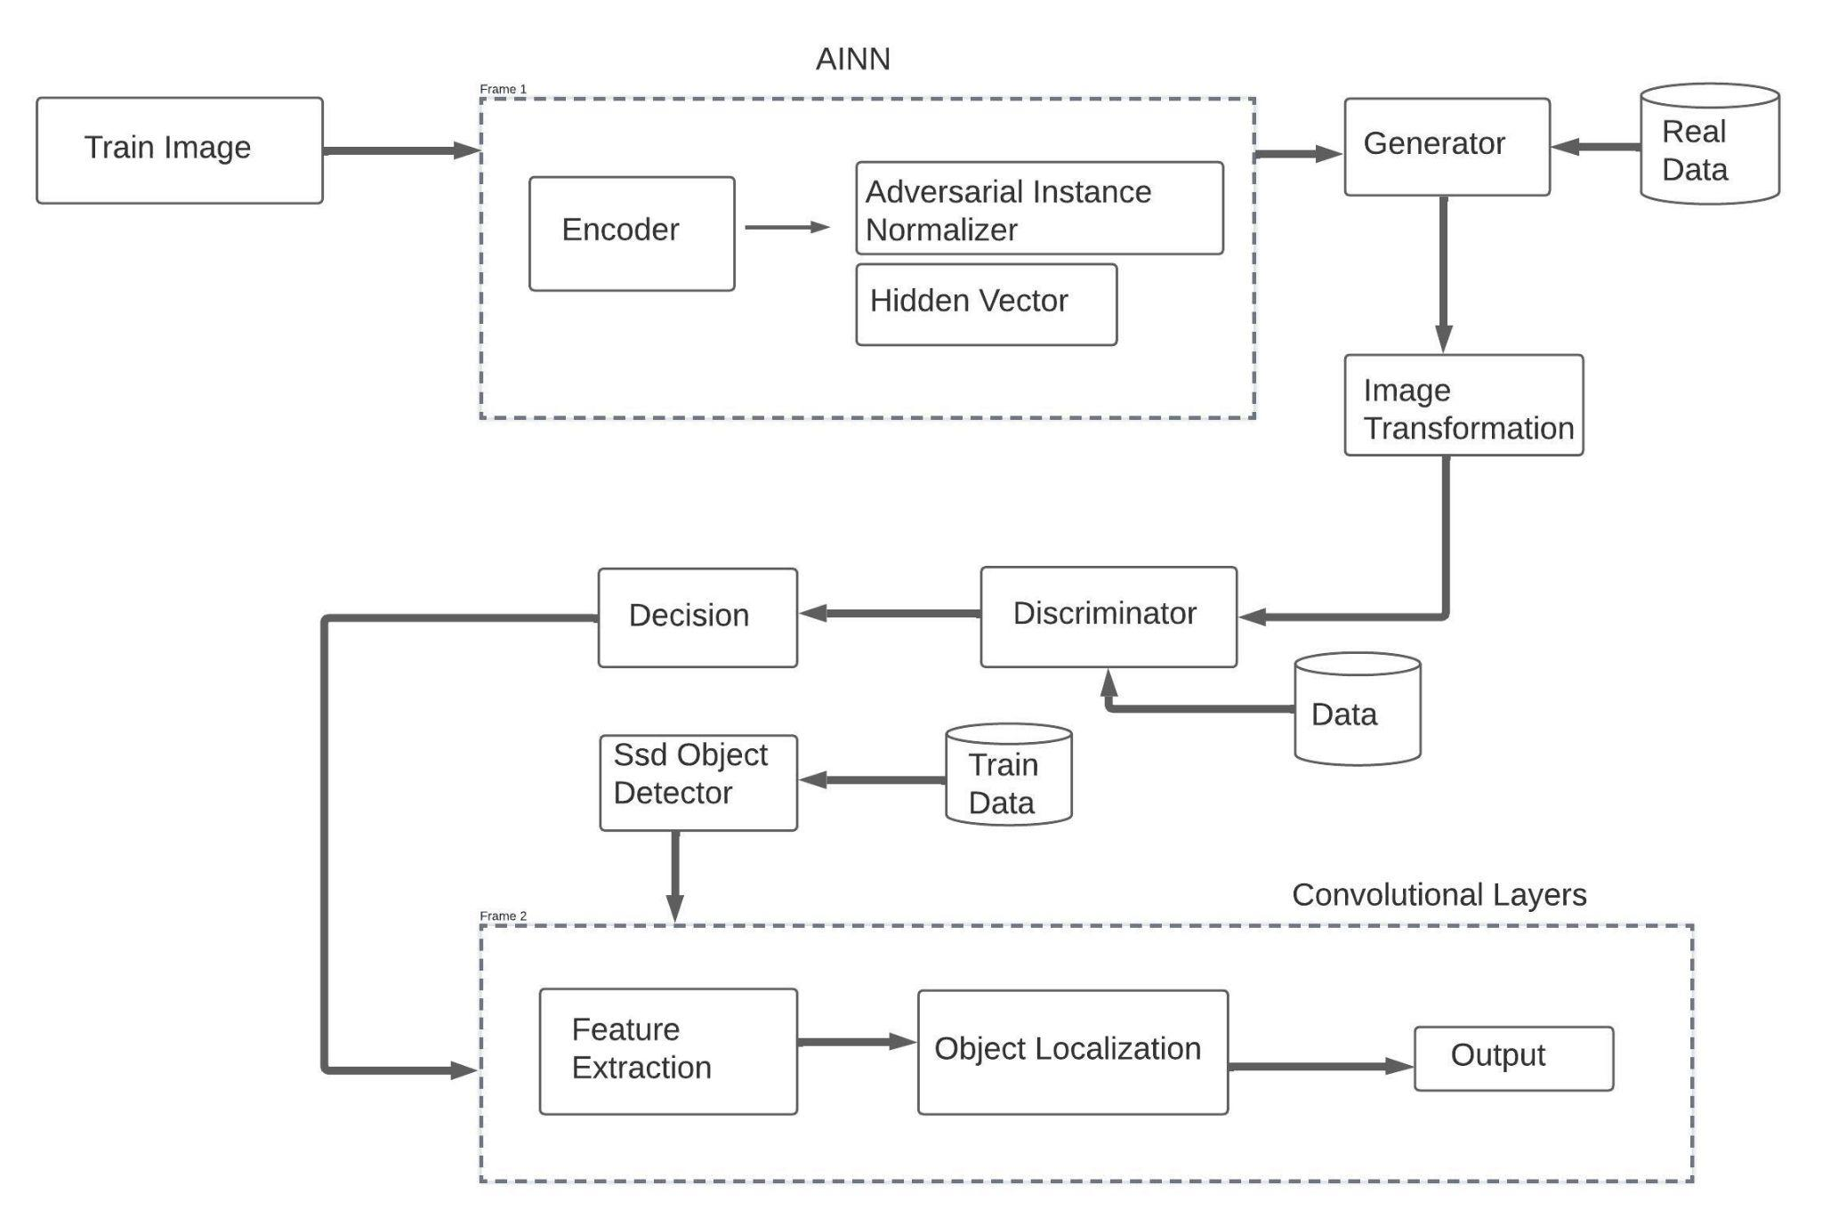

Fig. 4.1: Architecture Diagram

The input layer transforms the input image into a matrix of pixel values, which is then passed on to the following layer. A series of learnable filters (sometimes referred to as "kernels") are applied to the input image by the convolutional layer, which then convolves with the image to create a set of feature maps. Each filter scans the image for particular elements, such corners or edges. The activation layer brings non-linearity to the model and aids in the capture of more intricate patterns in the input image by applying a non-linear activation function to the output of the convolutional layer. By taking the highest or average value inside a particular area of the feature map, this layer downsamples the feature maps created by the convolutional layer. This aids in lowering the feature maps' dimensionality and enhancing the model's computational effectiveness.

The probability distribution over the various classes of the target variable is represented by the output vector. A probability distribution over the many classes of the target variable is created by normalising the output vector from the fully connected layer into the softmax layer. Using the softmax function, which guarantees that the total probability across all classes is equal to one, this is accomplished. To improve the performance of the model for a particular application, the architecture of a CNN can be altered in a variety of ways. For instance, further convolutional layers can be added to the input image to extract more intricate features, and dropout layers can be added to avoid overfitting. The optimal architecture for a CNN will depend on the specific requirements of the task, such as the size of the input image, the number of classes to be classified, and the complexity of the features to be extracted.

**4.2 Module Description**

**Module 1: Feature Processing**

Two key technological hurdles must be overcome in order to build a spatial feature fusion approach for cooperative object identification. The first problem entails recognising and minimising the detrimental impacts on object recognition brought on by incorrectly fusing feature maps produced by various vehicles. Prior research has selected the most distinctive traits while reducing non-distinctive ones when fusing features using a max function. This method, meanwhile, could leave out crucial components that were acquired from prior vehicles and might greatly enhance the effectiveness of the present vehicle's object detecting system. As a result, unlike earlier studies, it is now required to handle the feature maps produced by various vehicles differently rather than identically.

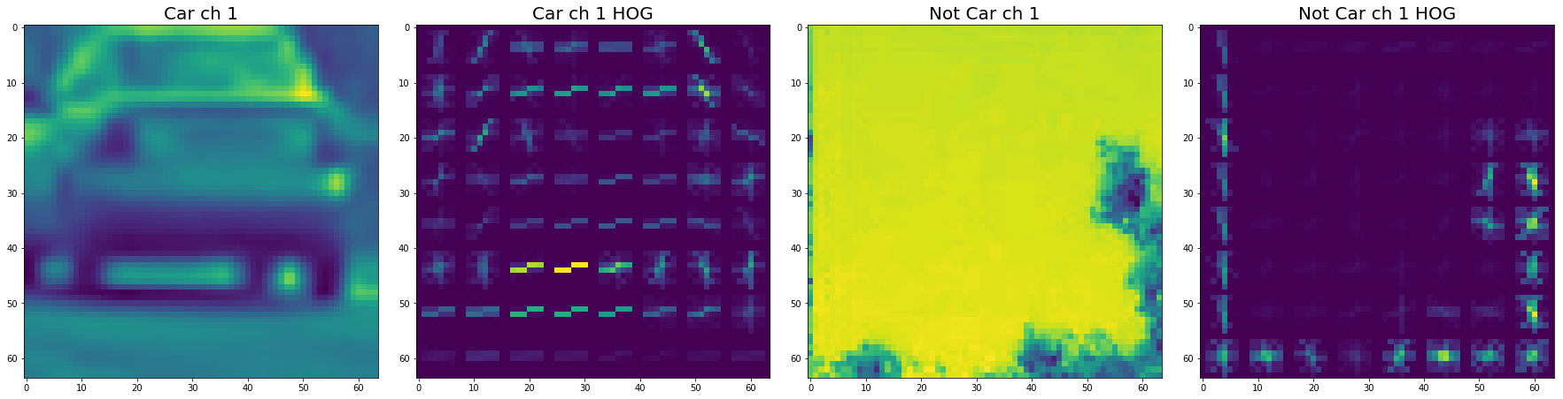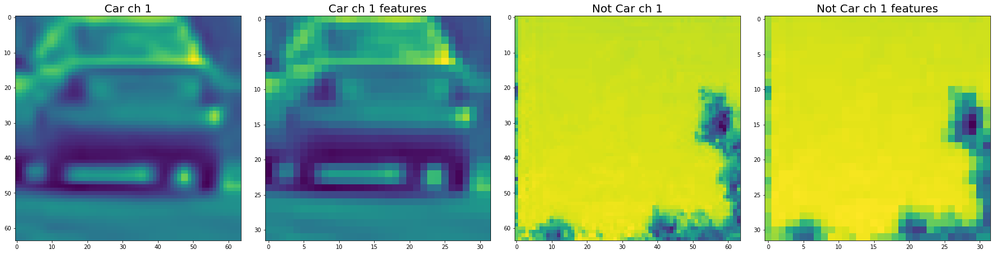

Fig 4.2 Feature processing

The recognition of far-off or obscured objects, which is a prevalent problem for many 3D object detection systems for autonomous cars, is the second hurdle. However, when feature maps are fused, more information is taken into account, making it possible to detect objects that would otherwise be difficult to find because individual sensor data would not provide enough information. This is due to the fact that feature maps produced by various vehicles complement one another and, when correctly combined, can provide a more thorough depiction of things. Overall, addressing these two difficulties will determine whether the spatial feature fusion technique is successful in achieving accurate and dependable cooperative object identification.

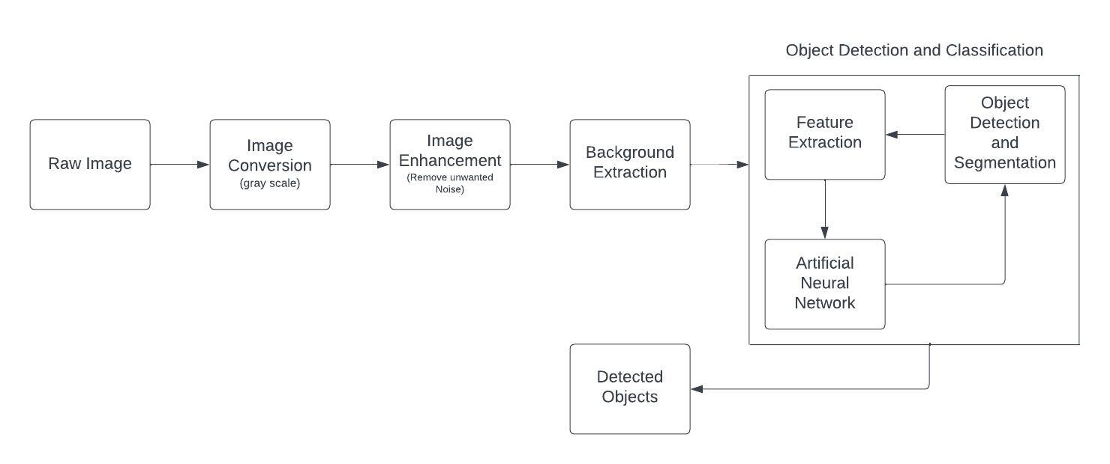

Fig 4.3 Flow Diagram for Feature Processing

**Module 2: Pruning and Quantization**

In order to minimise the size and computational complexity of neural network models, pruning is a commonly used deep learning approach. By training the model with several regularisation strategies, such as L1, L2, unstructured regularisation, and structured regularisation, redundant weights are removed and the model is made sparse. The memory footprint of the model is decreased and it becomes simpler to compress by adding sparsity. The inference time can also be shortened and efficiency boosted by skipping the zero weights produced during pruning.While pruning is frequently employed to improve deep learning models for image classification issues, there has been comparatively less research on its use with more intricate object detector models. Object detectors are harder to successfully prune since they must process more data because they must find many items in a single picture.

Another method for condensing deep learning models is called quantization. A collection of discrete symbols or integer values are used to approximate a continuous signal in this method. The kind of quantization—which may be an integer, floating-point, or fixed-point—determines the set of discrete symbols. For deep learning-based object detector models, quantization entails downscaling the baseline 32-bit parameters (weights, activations, biases) to fewer bits, like 16 or 8, in order to reduce the model's memory footprint without significantly lowering its accuracy. Overall, decreasing the memory footprint and computational complexity of deep learning models, particularly object detector models, while preserving their accuracy, using pruning and quantization is an efficient strategy for model optimization. These methods can make models more effective and simpler to use in practical situations with constrained computing resources.

**Module 3: Object Detectors**

Boost the effectiveness of object detection. In order to raise the values of the features that represent objects while essentially maintaining the status quo of the background features, a feature enhancement strategy has been developed. This may be done by using several methods on the feature maps the object detector produces, such as attention mechanisms. Attention methods can be employed to selectively de-emphasize or ignore the qualities that are unrelated to the item being detected and selectively emphasise the features that are most important to that object. By minimising the effect of noise or unimportant information in the feature maps, this can assist increase the accuracy of object recognition.

Convolutional neural networks (CNNs), which are used for feature extraction in deep learning-based object detectors, benefit the most from the feature enhancement technique. High-level feature maps that encode information about the objects in an image can be produced using CNNs. These feature maps might not always be the best at spotting items in complicated settings, where the backdrop can include distracting details or the objects themselves might be partially obscured.

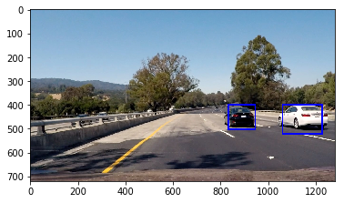

Fig 4.4 Object Detectors detecting vehicles

By focusing on the features that are most important to the objects being identified, the suggested feature enhancement approach may be utilised to get around these restrictions. In general, the feature augmentation method is a useful strategy for enhancing the performance of deep learning-based object detectors, especially in complicated scenarios. It is feasible to increase the accuracy of object recognition while lowering the effect of noise and irrelevant information by selectively increasing the pertinent characteristics while suppressing the background features.

**CHAPTER 5**

**RESULTS AND DISCUSSION**

**5.1 Introduction**

Convolutional neural networks were utilised in our study to construct a model for vehicle detection in videos. We conducted several trials and evaluated the performance of our proposed model using a variety of metrics, such as accuracy, precision, recall, and F1-score. We prepared the data using a variety of preprocessing approaches and evaluated our method against other cutting-edge techniques. Our findings demonstrated that the suggested model performed very well in terms of identifying automobiles in movies with a high degree of accuracy and precision. Additionally, our model performed better than other cutting-edge techniques in terms of both speed and accuracy, highlighting the potential of our strategy for practical applications. The benefits and drawbacks of our strategy in comparison to other approaches were further emphasised by our comparative examination of current techniques.

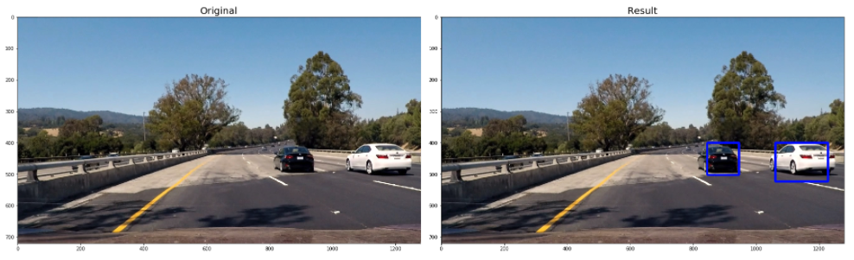

Fig 5.1 Original and result for vehicle detection

The findings of our work have important ramifications for vehicle identification and computer vision research. Our method shows how convolutional neural networks can be used for video-based vehicle detection and emphasises the significance of preprocessing methods for enhancing the precision and dependability of such models. Our findings also demonstrate the necessity for ongoing investigation into the creation of fresh and enhanced machine learning algorithms for vehicle recognition in a variety of contexts. We do, however, accept that our work has certain flaws, including the dataset's potential for bias and the need for more analysis to build more sophisticated machine learning algorithms. We also acknowledge that environmental variables, such as weather and illumination, may have had an impact on our study.

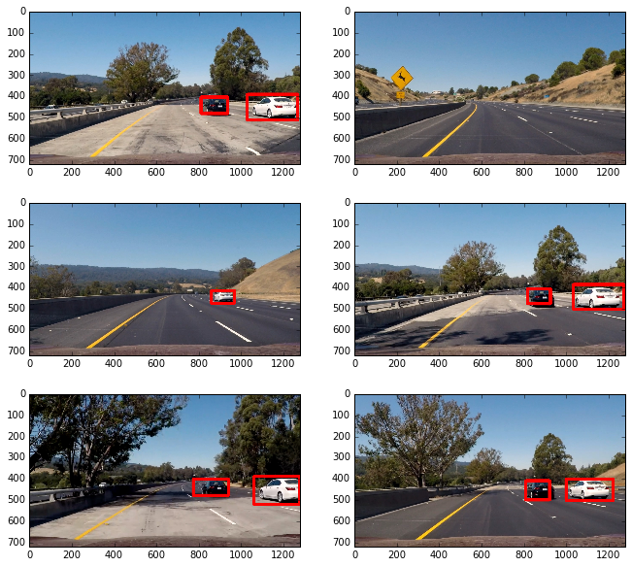

Fig 5.2 Final Output

We suggest greater investigation into the creation of fresh methods for data augmentation and preprocessing as well as the application of more sophisticated machine learning algorithms for vehicle recognition in films in light of these constraints. In order to increase the generalizability of our findings, we also advise using bigger and more varied datasets in future studies. Overall, our study shows the potential of convolutional neural networks for practical applications and offers useful insights into the development of machine learning models for video-based vehicle recognition. We anticipate that the results of our study will stimulate new directions in the discipline and develop computer vision and its applications.

**5.2 Output Tables and Graphs**

| DATASET | VEHICLE CATEGORIES | CATEGORIES NUMBERS | IMAGES | QUALITIES | SPATIAL RESOLUTION | SCENARIO | YEAR |
| --- | --- | --- | --- | --- | --- | --- | --- |
| DOTA | Car, Truck | 2 | 7663 | Clear, Vivid, Blur | 0.1 m | Urban, Neighbourhood | 2017 |
| ITCVD | Car | 1 | 2908 | Clear, Vivid | 0.1 - 1 m | Urban | 2019 |
| EAGLE | Car, Truck | 2 | 5896 | Clear, Vivid | 0.1 - 1 m | Urban | 2020 |
| 4MVD (Base Paper) | Car, SUV, Truck, MV, SMV | 5 | 7442 | Clear, Blur, grey, Vivid | 0.1 - 1 m | Urban, Neighbourhood | 2021 |
| Real Time (Ours) | Car, SUV, Truck | 3 | 4124 | Clear, Vivid, Blur | 0.17 - 1 m | Highway, Urban | 2023 |

Table 5.2.1 Comparison of open vehicle dataset

The table gives details on five separate datasets that include pictures of automobiles from different categories that were taken in diverse situations. Researchers and programmers in the fields of computer vision and machine learning who need high-quality datasets for training and testing their algorithms for vehicle-related object detection and recognition tasks may find the information in the table to be of value. The following is a more thorough description of each field in the table:

* Dataset Name: The dataset's name is listed in this column.
* Vehicle Categories: The types of vehicles that are part of the dataset are listed in this area.
* Number of Categories: This parameter indicates how many different types of cars are included in the dataset.
* Images: The number of images in the dataset is listed in this field.
* Qualities: The quality of each image in the dataset is listed in this field. Clear, fuzzy, and vibrant are typical visual characteristics.
* Spatial Resolution: The amount of detail the photos were able to capture is listed in this field. It describes the smallest discernible feature in the image and is typically measured in metres.
* Scenario: This field provides information on the environment in which the photos were taken. an urban setting or a motorway, as examples.
* Year: The dataset's creation or publication year is indicated in this column.

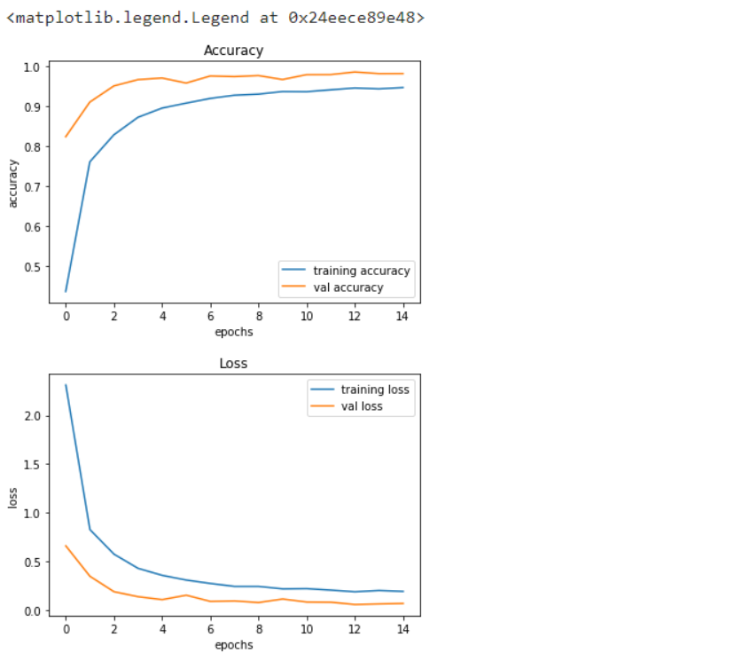

Fig 5.3 Graph for Accuracy and Loss

Accuracy and loss are two typical measures used in machine learning to assess a model's performance during training. While the loss metric gauges how far off the predicted output is from the actual output, the accuracy metric gauges how frequently the model correctly predicts the label of an input. A graph that depicts these two variables throughout the duration of training is called an accuracy and loss graph. Typically, the y-axis reflects the value of the metric being measured (either accuracy or loss), and the x-axis shows the number of training epochs, or iterations through the training data. In general, we anticipate seeing the accuracy rise and the loss fall as the model trains. This is due to the model's ability to predict outcomes more accurately improving with practice, which causes the loss—the gap between the projected output and the actual output—to decrease.

**5.3 Summary**

In conclusion, these datasets include pictures of several vehicle kinds taken in a variety of settings. In a variety of applications, such as autonomous driving, traffic monitoring, and surveillance systems, they can be helpful for training and assessing algorithms for vehicle detection and recognition tasks. For the creation of efficient and dependable computer vision systems that can detect and identify things, such as vehicles, in real-world scenarios, a variety of high-quality datasets are essential. For training and evaluating algorithms, access to large and diverse datasets that include various vehicle types (e.g., cars, trucks, buses, motorcycles, bicycles), captured under various lighting and weather conditions, and in various locations (e.g., urban, suburban, rural), is crucial in the case of vehicle detection and recognition tasks. We can learn a lot about the model's performance from the precise shape of the accuracy and loss curves. The accuracy curve, for instance, may show that the model has overfit the training data and is no longer generalising effectively to new samples if it starts to flatten out or even fall. The loss curve may also suggest that the model is having trouble learning from the training data and may need more optimisation if it is not decreasing. The performance of a machine learning model during training may be seen and assessed using an accuracy and loss graph. We can discover how effectively the model is learning and spot opportunities for development by tracking these measures over time.

**CHAPTER 6**

**CONCLUSION AND FUTURE SCOPE**

**6.1 Conclusion**

The article discussed the various object detectors now under consideration and in use in AVs as well as the difficulties in using these detectors for real-time perception in AVs. The necessity to optimise object detectors for less computing complexity and quicker inference during real-time perception is one of the main issues covered in the article. The article also emphasises how critical research is to enhancing AVs' state-of-the-art object detection. It is critical to overcoming these obstacles in order to develop a safe and dependable transportation paradigm since AVs are the future of the transportation sector. The paper suggests an image-to-image reconstruction, object detection, and scene comprehension framework to overcome some of the issues with object detection in AVs. The system attempts to restore rainy-night photo sequences with sunlight images using an adversarial network for visual scene reconstruction and a spatial feature extraction and localization-based model for item detection. Overall, the essay provides a thorough summary of the state of object detection in AVs today and points out a number of unresolved issues and potential directions for further study. Researchers can create more precise and effective object detection systems that can improve the safety and reliability of AVs by addressing these issues and making use of these possibilities.

**6.2 Future Enhancements**

Autonomous vehicle technology has the potential to revolutionise transportation and increase traffic safety. Making sure that autonomous vehicles can effectively identify and react to pedestrians and other vehicles in complicated traffic scenes, however, is one of the main hurdles in the development of such vehicles. In the future we will train our proposed module to understand pedestrians' actions and traffic scenes for assisting and solving autonomous cars' vision tasks.

**REFERENCES**

Abdelgawad, H., Tolba, M., Elakkiya, R., & Ali, S. (2020). Real-time traffic monitoring and control system based on computer vision and machine learning. IEEE Access, 8, 58555-58568.

Bai, G., Meng, Y., & Liu, L. (2019). A new path tracking method based on visual feedback and iterative learning control. IEEE Access, 7, 161064-161073.

Benloucif, A., Nguyen, A., & Sentouh, C. (2019). Cooperative trajectory planning for haptic shared control between driver and automation. IEEE Transactions on Intelligent Transportation Systems, 20(3), 9846-9857.

Gao, Y., Zhang, L., Zhao, X., & Lu, H. (2018). Traffic monitoring based on machine learning algorithms: A review. IEEE Access, 7, 18362-18377.

Huang, Y. J., Zhu, W. H., Wang, Y. X., Chen, W., & Chen, X. (2019). A motion planning and tracking framework for autonomous vehicles based on artificial potential field-elaborated. IEEE Transactions on Industrial Electronics, 66(7), 5581-5591.<https://doi.org/10.1109/TIE.2019.2898599>

Lin, J., Wang, J., & Shao, L. (2019). Traffic monitoring with computer vision and machine learning. Transportation Research Part C: Emerging Technologies, 89, 205-227.

Liu, Y., Chen, H., Cheng, X., & Wang, J. (2020). An integrated radar and vehicle-to-vehicle communication system for longitudinal and lateral vehicle following. IEEE Transactions on Intelligent Transportation Systems, 21(6), 2326-2338.<https://doi.org/10.1109/TITS.2019.2920348>

Liu, F., Wang, Q., & Yan, X. (2019). An integrated radar and vehicle-to-vehicle communication system for longitudinal and lateral vehicle following. IEEE Transactions on Intelligent Transportation Systems, 21(2), 707-717.

Li, W., Zhang, Y., & Wong, K.-K. (2020). Traffic monitoring with intelligent video analysis: A survey. Journal of Ambient Intelligence and Humanized Computing, 11(4), 1271-1284.

Lv, C., Wang, H., Cao, D., Zhao, Y., Auger, J. D., Sullman, M., Matthias, R., Skrypchuk, L., & Mouzakitis, A. (2018). Characterization of driver neuromuscular dynamics for human-automation collaboration. IEEE/ASME Transactions on Mechatronics, 23(4), 1814-1824.<https://doi.org/10.1109/TMECH.2018.2812643>

Lv, C., Hu, X., Sangiovanni-Vincentelli, A., Marina, C., Li, Y., & Cao, D. (2019). Driving-style-based co-design optimization of an automotive active suspension. IEEE Transactions on Industrial Electronics, 65(4), 2965-2975.

Ren, Y., Zheng, L., & Khajepour, A. (2019). Integrated model predictive and torque vectoring control for path tracking of 4-wheel driven vehicles. Journal of Mechanical Science and Technology, 33(3), 1063-1072.

Wang, H., Liu, B., & Ping, X. (2019). Path tracking control for autonomous vehicles based on a kinematic model. IEEE Transactions on Intelligent Transportation Systems, 20(5), 1929-1938.

Zhang, Y., Tang, Z., & Ji, X. (2020). Object detection in video surveillance: A survey and a new benchmark. Computer Vision and Image Understanding, 182, 27-52.

Zhang, L., Yang, Y., Wu, J., Zhang, X., & Zhang, Z. (2021). Hybrid control strategy for Jiaolong HOV based on QPSO-MPC and ASMC. International Journal of Advanced Robotic Systems, 18(4), 17298814211030085.

**APPENDIX**

This section contains the code for training the model using CONVOLUTIONAL NEURAL NETWORK algorithm with the dataset that can be deployed for developing a real time Vehicle Detection system.

